Foundation & Core OS Skills
Goal: To master basic VM management, OS installation, and fundamental operating system administration for both Windows and Linux.
1. Introduction (Build Your Workbench)
This section sets the stage, outlining the goal of mastering basic VM management and OS administration for both Windows and Linux. It defines the primary lab environment as a single host machine running VirtualBox, hosting several interconnected Virtual Machines (VMs): a Windows Server (DC01), a Windows client (W10-Client01), and a Linux client (Ubuntu-Client01). It also specifies the initial network setup for each VM, emphasizing the use of a NAT adapter for internet access on the server and an "Internal Network" (IT_Lab_Network) for all VMs to communicate securely within the lab.
2. Virtualization Environment Setup & VM Deployment
This is the hands-on start to creating your lab. It involves:
- Installing VirtualBox on your physical host machine.
- Downloading the necessary Operating System ISOs (Windows Server, Windows 10/11, Ubuntu Desktop) to serve as installation media.
- Creating the virtual machines (VMs) themselves within VirtualBox (DC01, W10-Client01, Ubuntu-Client01). This includes allocating virtual hardware resources like RAM and hard disk space.
- Configuring the network adapters for each VM before OS installation. This involves setting up Adapter 1 as NAT and Adapter 2 as IT_Lab_Network for DC01, and Adapter 1 as IT_Lab_Network for both client VMs. The challenge here often involves enabling Adapter 2, which is disabled by default in VirtualBox settings.
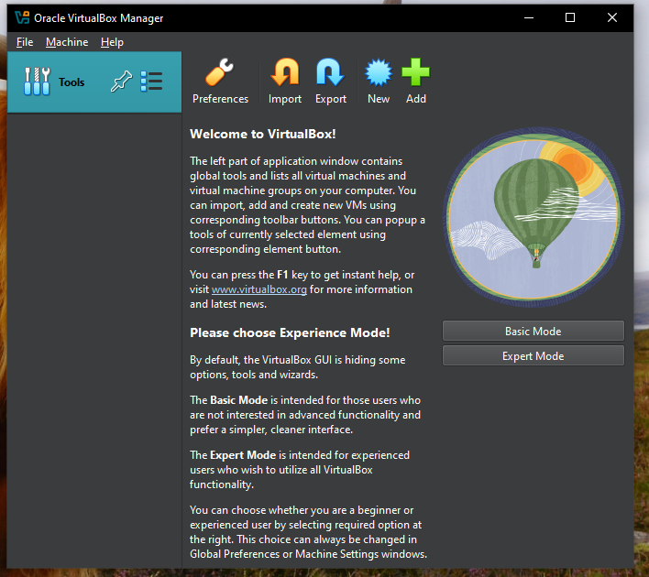

3. Operating System Installation
This section focuses on the actual installation of the chosen operating systems onto your newly created VMs:
- Installing Windows Server 2022 on DC01: The critical point here is ensuring you select the "Desktop Experience" version during installation to get the graphical user interface (GUI), rather than the command-line-only "Server Core" version.
- Installing Windows 10/11 on W10-Client01: A standard client OS installation.
- Installing Ubuntu Desktop on Ubuntu-Client01: The process for setting up a Linux desktop environment.
- Installing VirtualBox Guest Additions: This crucial step involves installing drivers and utilities within each VM that enhance performance and integration with the VirtualBox host (e.g., better display resolution, shared clipboard, drag-and-drop).
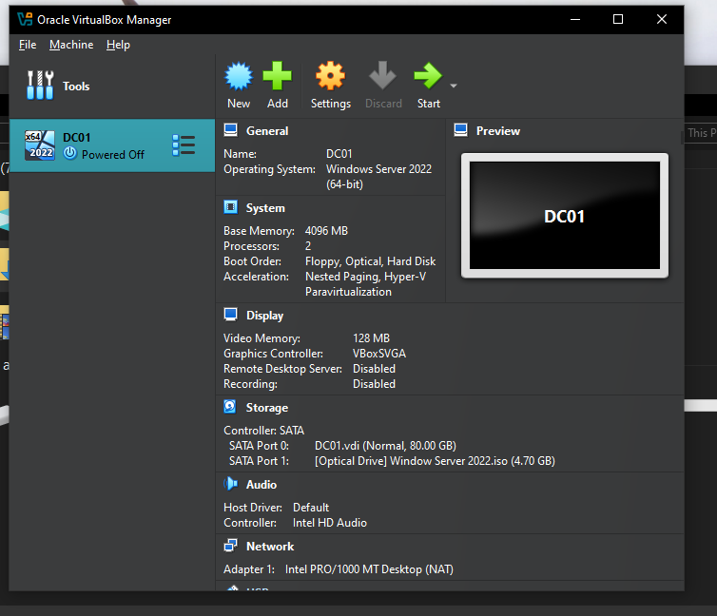
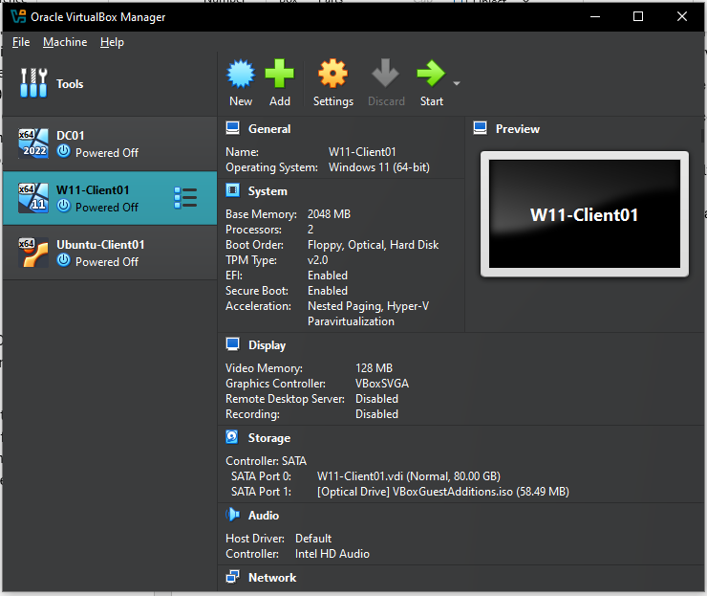
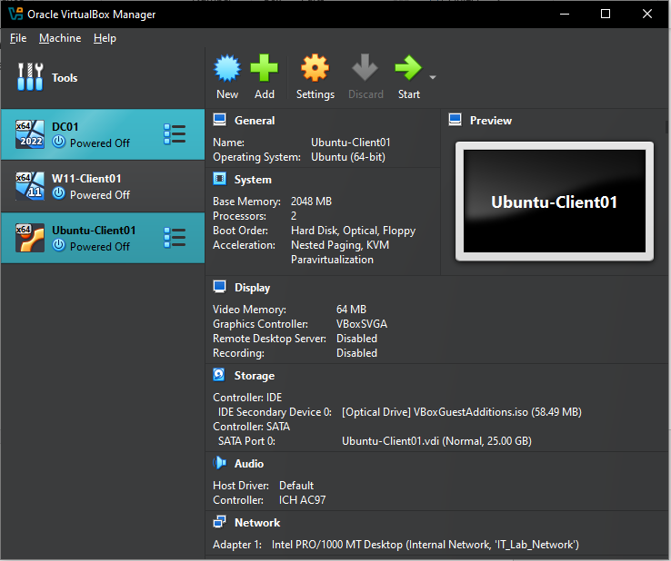
4. Fundamental OS Administration (Initial Setup)
Once the operating systems are installed, this part covers the immediate post-installation configuration to make your lab functional and consistent:
- Renaming Computers: Assigning meaningful hostnames (DC01, W10-Client01, Ubuntu-Client01) for easier identification.
- Configuring Static IP Addresses: Manually assigning IP addresses, subnet masks, gateways, and DNS servers to the internal network adapters (IT_Lab_Network) of all VMs. This is a critical step for controlled lab communication.
- Temporarily Disabling Firewalls: For lab simplicity and ease of initial connectivity testing, firewalls (Windows Defender Firewall, Ubuntu's UFW) are temporarily disabled. Note: In a real-world scenario, you would configure specific firewall rules, not disable them.
- Managing SConfig (Windows Server): Understanding that SConfig (Server Configuration Tool) auto-launches on Windows Server and knowing how to disable its auto-launch behavior to access the full desktop GUI.
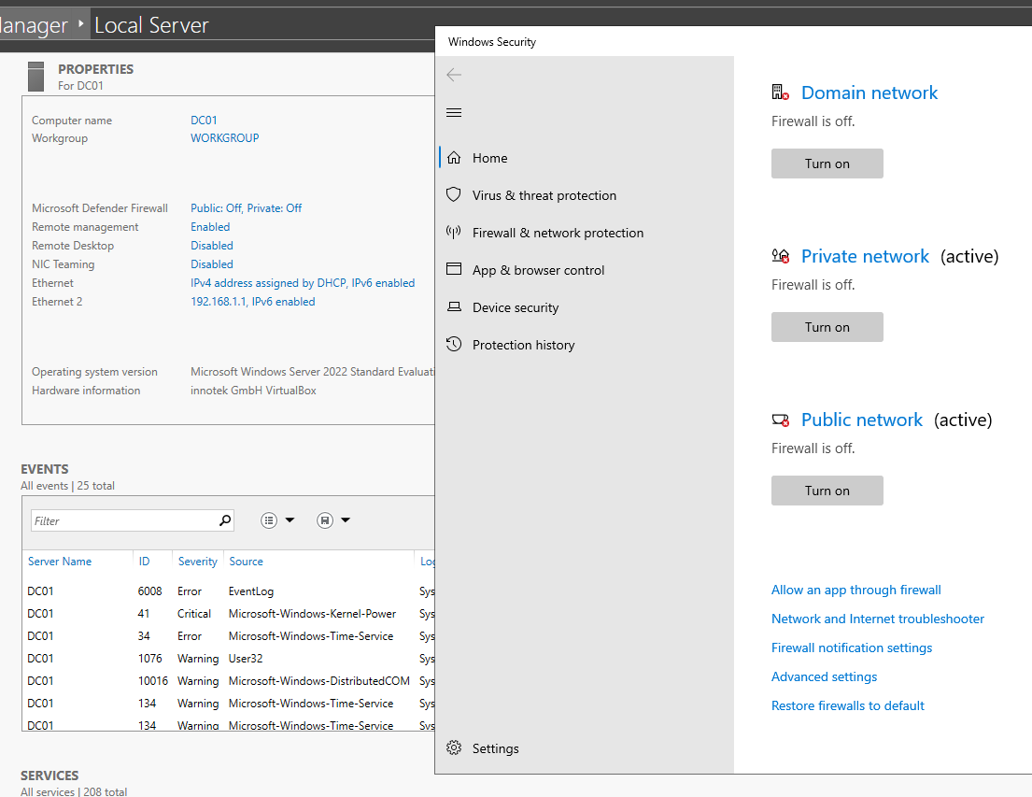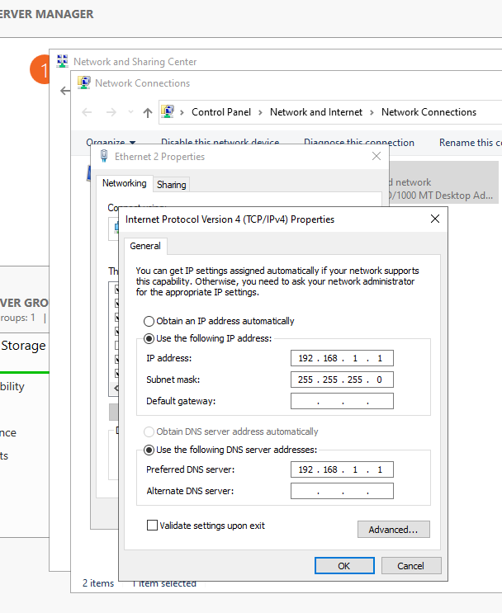

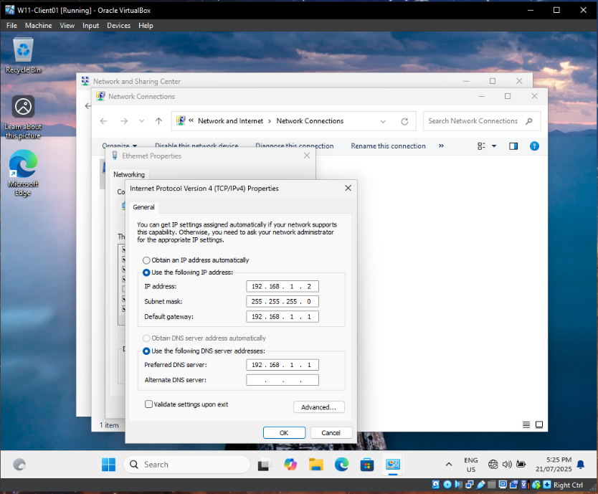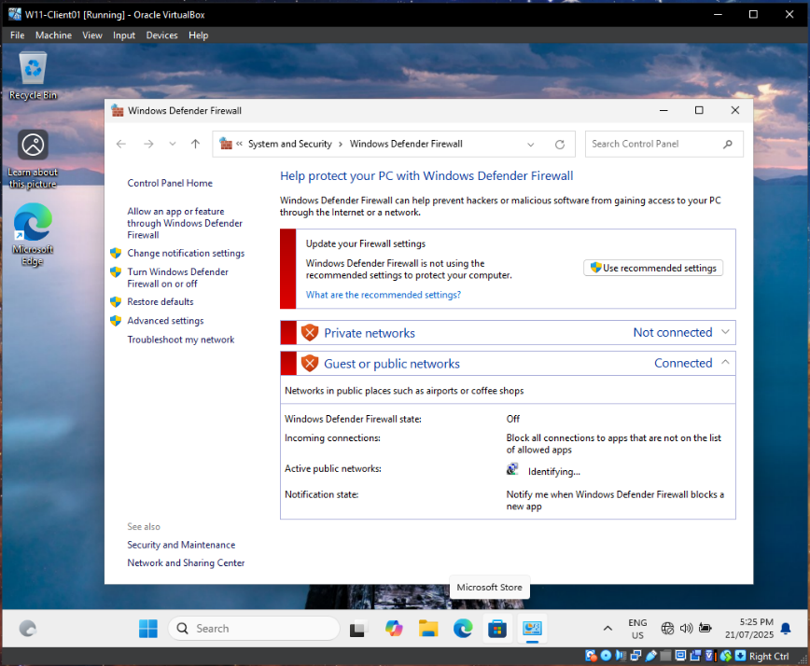

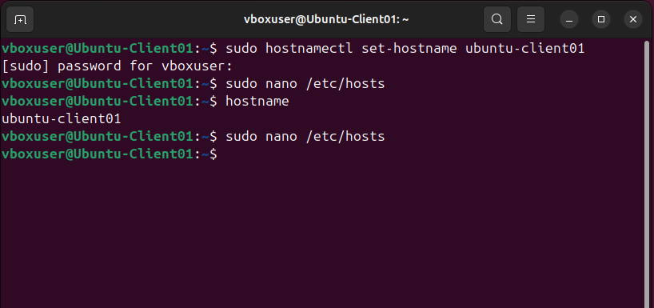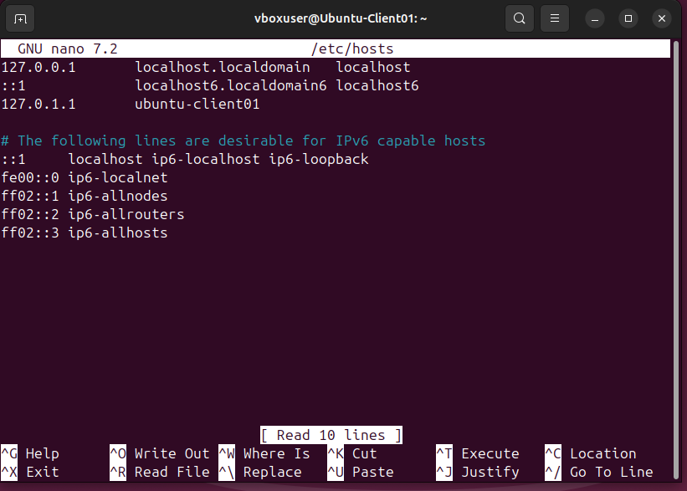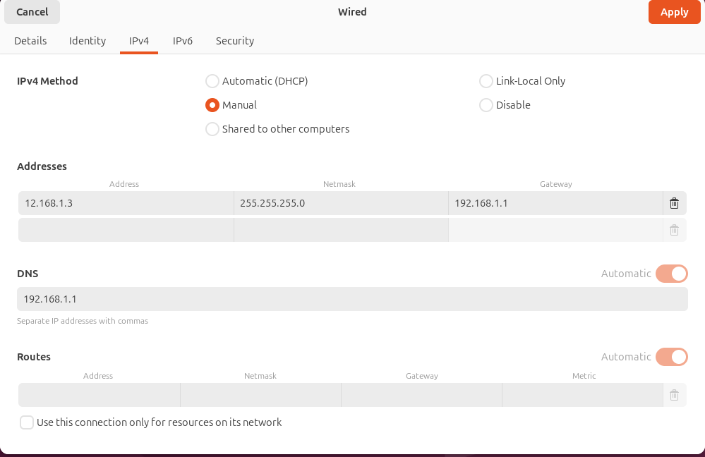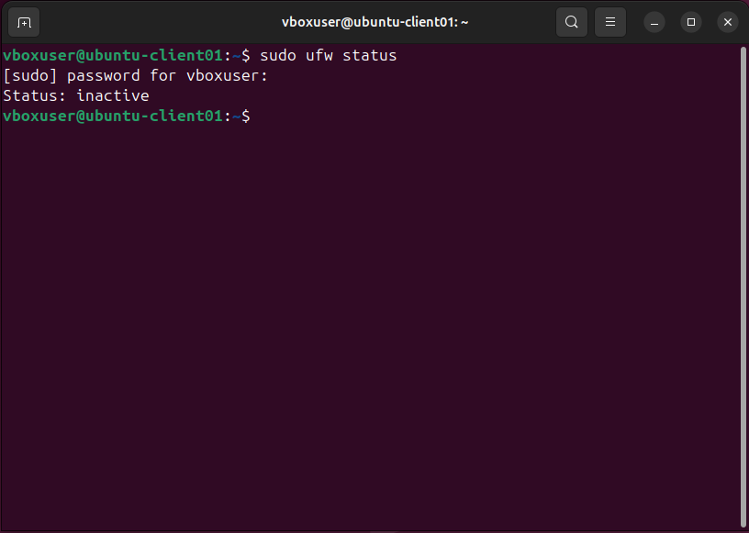

5. Network Connectivity Testing
This final step validates your initial network configurations, ensuring your VMs can communicate with each other over the IT_Lab_Network:
- Pinging VMs: Using the ping command (from both Windows Command Prompt/PowerShell and Linux Terminal) to verify basic IP-level connectivity between DC01, W10-Client01, and Ubuntu-Client01 using their newly assigned static IP addresses.
- Initial Name Resolution Check (Optional/Baseline): A brief check using nslookup to see if hostnames are resolving, acknowledging that full DNS resolution will be configured in later lab phases.
